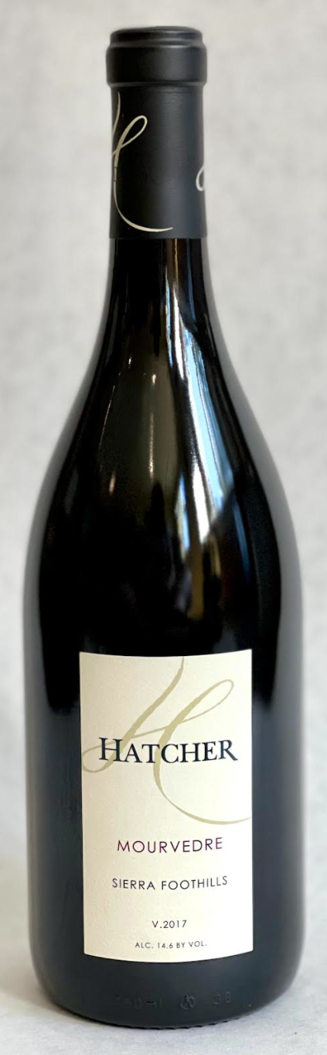\

**2017 Hatcher Mourvedre**

**Tasting Notes**

.Fruit from El Dorado County in California.  Aged 30 months in French and Hungarian oak.  Aromas of tobacco, earth and rhubarb.  Savory flavors of raspberry, tart strawberry and pomegranate.  Medium bodied with a long finish.  Pair with grilled duck breast

**Wine Specs**

Alcohol: 14.6%

PH: 3.60

Acidity: 7.2

Appellation: Sierra Foothills

Pick date: October 5, 2017

Winemaker: Matthew Hatcher

Release date: June 2020

