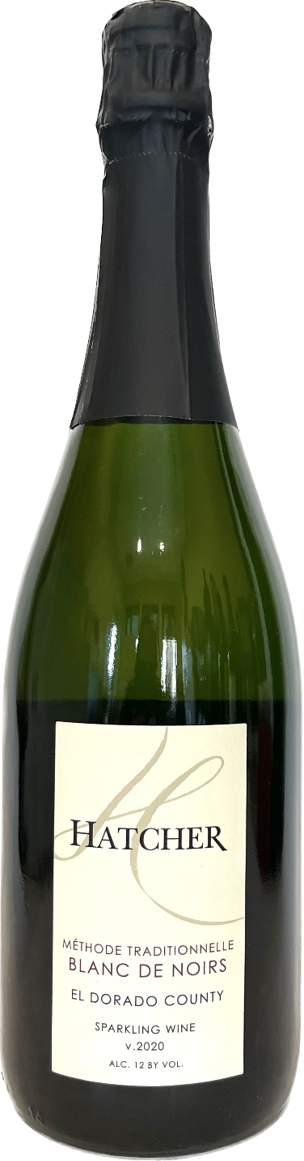

**2020 Hatcher Blanc de Noirs Sparkling**

**Tasting Notes**

Pinot Noir grapes from Duarte Vineyard in Georgetown at an elevation of 2400 feet in the El Dorado County appellation. This Brut Sparkling was m**ade using the Methode Traditionnelle process; a true 2nd fermentation in the bottle. Hints of yeast on the nose from a t**wo-year en tirage. Flavors of Fuji apples and ripe pears. Long lasting bubbles with a bright, elegant finish.

**Wine Specs**

Alcohol: 12%

PH: 3.3

Acidity: 7.2

Appellation: El Dorado County

Pick date: September 12, 2020

Winemaker: Matthew Hatcher

Release date: December 2022

