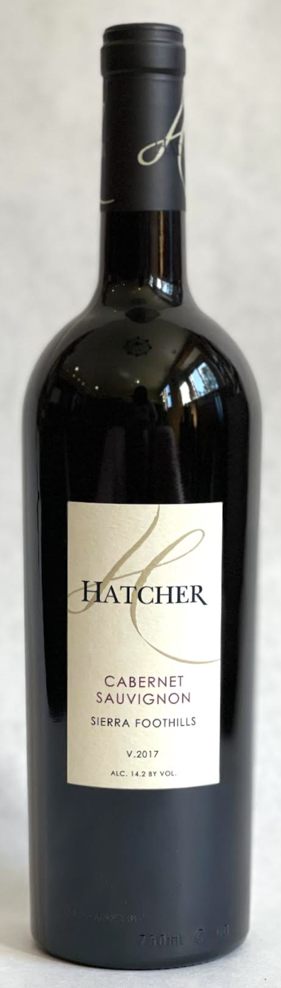\

**2017 Hatcher Cabernet Sauvignon**

**Tasting Notes**

Fruit from Duarte’s “Georgetown Vineyard”, El Dorado County, California.  45 day extended maceration.  30 months American oak, 20% new.  Aromas of vanilla, dark cherry and cinnamon graham cracker.  Flavors of dark cherry, plum and blackberry.  Balanced with silky smooth tannins.

**Wine Specs**

Alcohol: 14.2%

PH: 3.68

Acidity: 6.3

Appellation: Sierra Foothills

Pick date: October 8, 2017

Winemaker: Matthew Hatcher

Release date: September 2020

