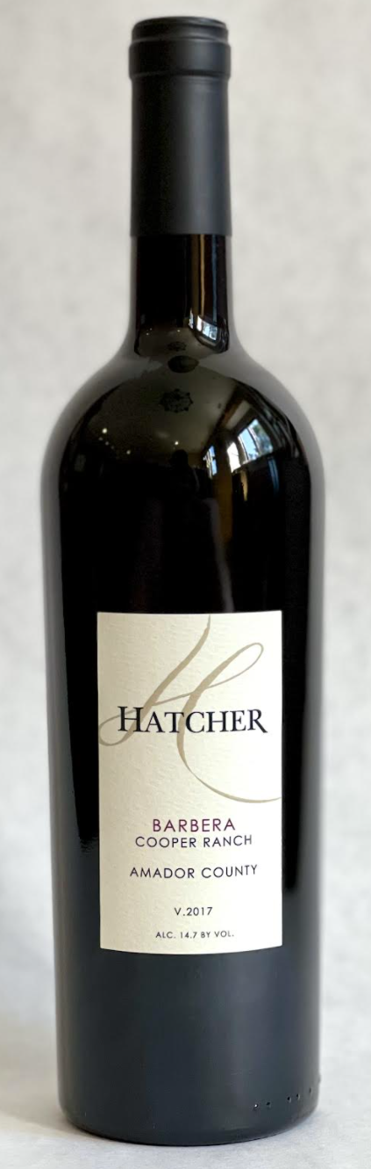\

**2017 Hatcher Barbera**

**Tasting Notes**

Fruit from Cooper Ranch in Amador County, California.  Aged 24 months in American oak.  Aromas of oak, blackberry and plum.   Flavors of ripe plum, black cherry and vanilla.  This wine pairs well with a fall menu.  Hearty comfort food, like pasta with marinara or lasagna.

**Wine Specs**

Alcohol: 14.7%

PH: 3.51

Acidity: 6.8

Appellation: Amador County

Pick date: September 21, 2017

Winemaker: Matthew Hatcher

Release date: September 2020

