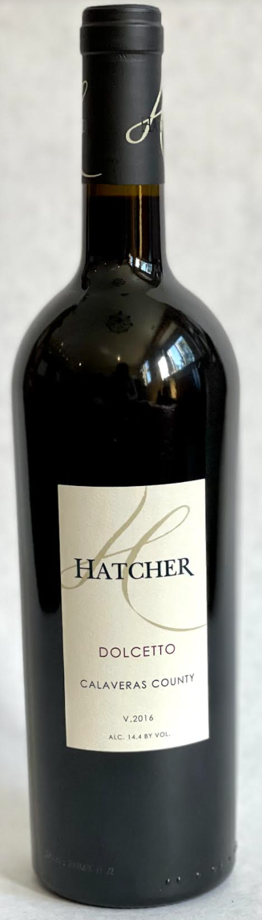\

**2016 Hatcher Dolcetto**

**Tasting Notes**

Fruit from Clondaire Vineyard in Calaveras County. Aged twenty-four months in 25% new American oak. Aromas of raspberry, and red currant. Flavors of bright fruit tones, soft acidity and rich tannin. Hints of chocolate and leather. Raspberry jam and coffee on the finish. Pairs well with an artisan pizza.

**Wine Specs**

Alcohol: 14.4%

PH: 3.61

Acidity: 5.6

Appellation: Calaveras County

Pick date: October 15, 2016

Winemaker: Matthew Hatcher

Release date: September 2019

