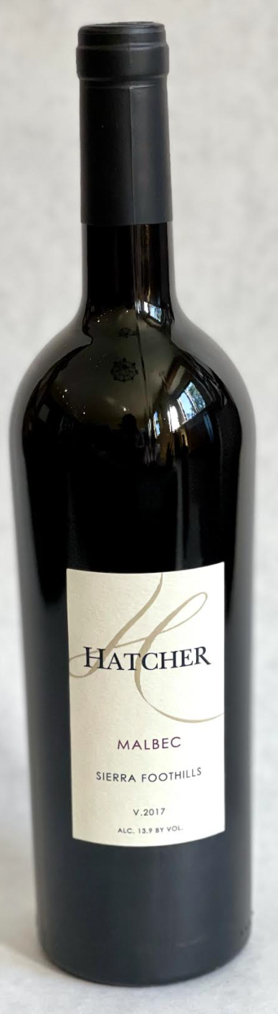\

**2017 Hatcher Malbec**

**Tasting Notes**

Fruit from our Tyee Vineyard in Vallecito, California and from Gold Bud farms in El Dorado County.  28 months, 35% new French oak.  Blueberry, blackberry and cherry with healthy tannins.  Lovely aromas of French oak.  Excellent with Beef Bourguignons.

**Wine Specs**

Alcohol: 13.9%

PH: 3.53

Acidity: 6.1

Appellation: Sierra Foothills

Pick date: October 5, 2017

Winemaker: Matthew Hatcher

Release date: January 2021

