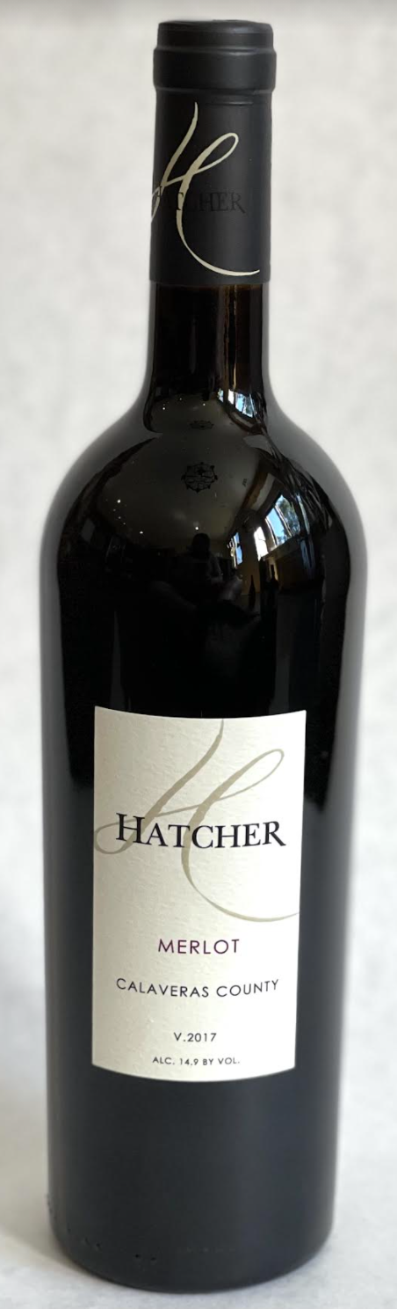\

**2017 Hatcher Merlot**

**Tasting Notes**

Fruit from Six Mile Vineyard, in Calaveras County.  Aged 31 months, 35% new French oak.  Ripe blueberry, raspberry and cranberry.  Soft and easy to love.  Perfect with a bacon cheeseburger.

**Wine Specs**

Alcohol: 14.9%

PH: 3.60

Acidity: 7.2

Appellation: Calaveras County

Pick date: October 4, 2017

Winemaker: Matthew Hatcher

Release date: January 2021

